Juvenile Delinquency
Name
Institution
Date

Juvenile Delinquency
For this assignment, the problem of focus in the data collection is juvenile delinquency. Juvenile delinquency can be defined as the involvement or participation by minor children who are between the ages of 10-17 in illegal activities or behaviours. Juvenile delinquency also describes children who have persistent behaviours of disobedience and mischievousness. The behaviours are primarily associated to lack of parental control, truancy, underage drinking and peer influence. Juvenile delinquency has been a main problem in the United States for many years, and as such, this has affected the set-up of society. Per every single year, around 2.1 million youths who are under the age of 18 are arrested in different prisons in the United States (Siegel & Welsh, 2016). On the same note, 1.7 million cases related to delinquency are disposed in different courts per year. The table and pie chart below show that child delinquency is a very critical criminal justice problem in the United States.
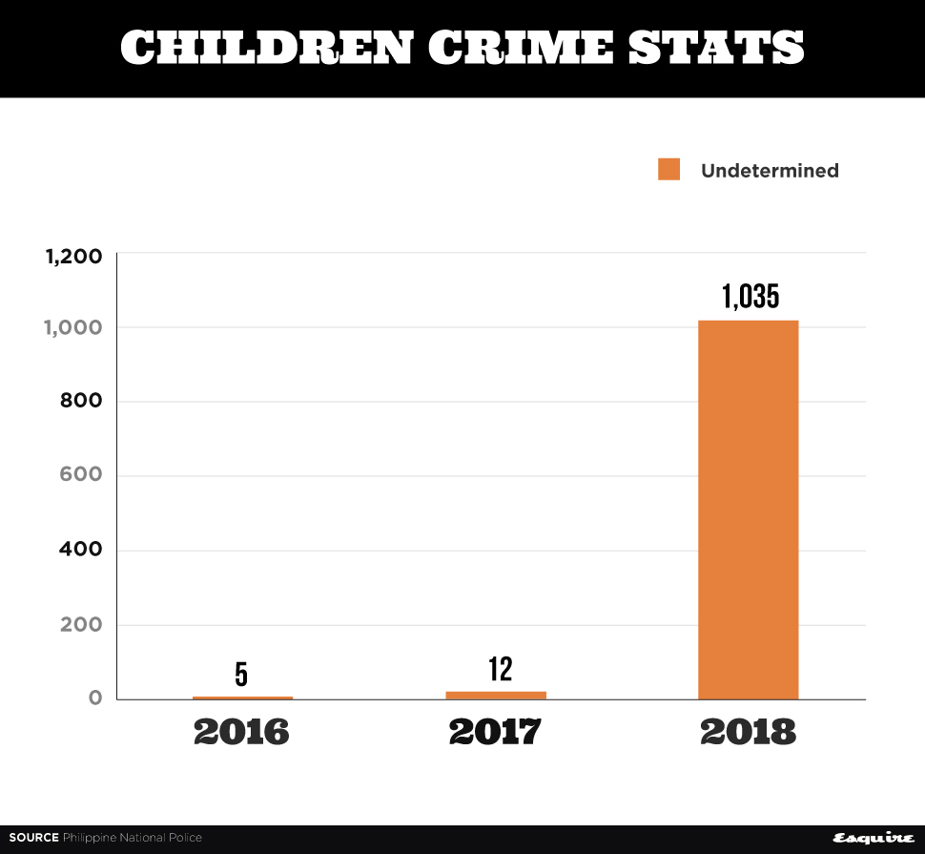
According to this chart, it is evident that crimes committed by children have continued to increase from 2016-2018. Some of the examples of crimes which are conducted by children are rape, robbery and kidnapping. As such, juvenile delinquency cases have increased although many of undermined in 2018.
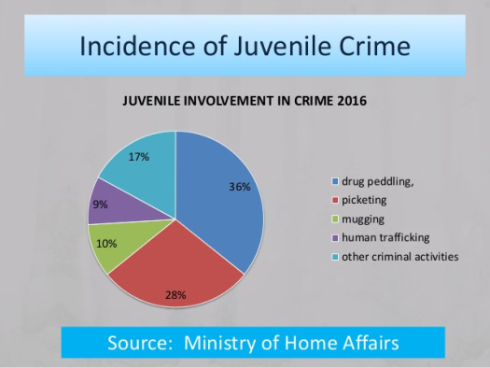
According to this pie chat, juvenile crime cases such as drug peddling, picketing, mugging, human trafficking and other criminal activities are defined according to their frequency. Picketing and drug peddling are the main crimes that are carried out by juveniles. In other words, this shows that the problem of juvenile crimes is severe in the United States (Thompson & Bynum, 2016). Counsellors and public institutions are some of the stakeholders that influence decision making when juveniles are making decisions. Parents and guardians are the personal stakeholders, and as such, they should provide their children with parental guidance to ensure they do not engage in illegal activities. On the same note, juveniles should avoid being ruined by peer pressure both in school and school.

References
Siegel, L. J., & Welsh, B. C. (2016). Juvenile delinquency: The core. Nelson Education.
Thompson, W. E., & Bynum, J. E. (2016). Juvenile delinquency: A sociological approach. Rowman & Littlefield.

